PRODUCT REQUEST FORM
PRODUCT NAME: | Plastic Bottle with Metered Pump
DESCRIPTION OF REQUEST:  - New Product  - Modification  - Product Extension  - Country addition  - Label Change  - Intended Use  -…Etc… | Plastic Bottle with Metered Pump, a critical delivery system designed specifically for sublingual immunotherapy (SLIT). This product is designed to capture a specific high-opportunity segment within the expanding allergy clinics market and strengthen our portfolio’s competitiveness.  Project Background  The U.S. allergy immunotherapy market is experiencing robust growth, with a valuation of $9.49 billion in 2024 and a projected CAGR of 7.5% to reach $19.56 billion by 2034. A key driver of this growth is the increasing adoption of Sublingual Immunotherapy (SLIT), favored for its convenience and home-based administration. Within the consumables segment (valued at $2.8-$3.5 billion), precise and reliable allergen extract delivery is paramount for both treatment efficacy and patient safety.  By establishing a "one-stop total solution" for Allergy Clinics Channel, we can engage more deeply across the entire allergy patient journey—from diagnosis (Skin Prick Tests, Blood Tests) to treatment (SLIT/SCIT) and ongoing management.  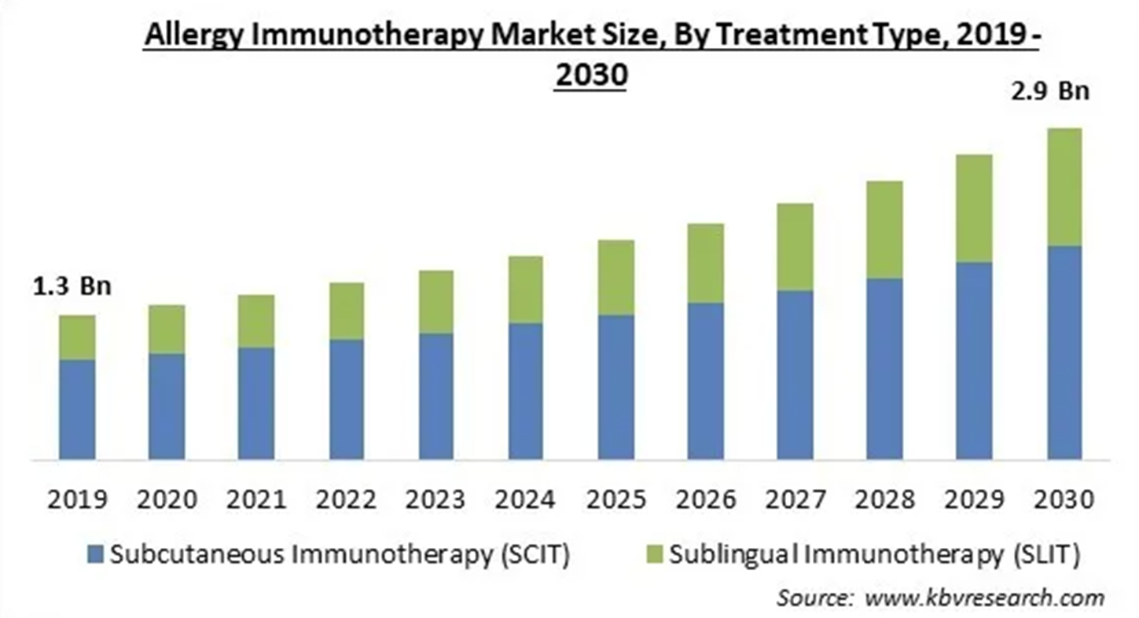
PURPOSE OF REQUEST: | ☐Complaint No. ☐Supplier ☒New market_______US_________  ☐Customer ___ ☐Internal _ ☐Other________________________  Add details:
ESTIMATED BENEFITS: | ☒ Financial Benefit: Complete the product lines for the allergy clinics markets, Annual sales amount $2.3M (Mandatory For NPD request)  Estimate the potential increase in cash flows, revenues, or any other financial benefits  ☐ Cost Saving:__________  Decrease in the cogs, transportation or operation expenses, or any other cost-saving opportunities  ☐ Improved Operational Efficiencies:_________  Decrease in the Lead time, delivery time, MOQ, Inventory, or any other efficiency improvement  ☐ Non-Financial Benefits:_________  Quality Improvement; Enhanced customer satisfaction, product competition, Brand reputation, etc.  ☐ Other Benefits:__________
PRODUCT DESCRIPTION:  - Functional performance requirements  - Appearance  - Any unique points of differentiation against similar competitor product lines  . ..Etc… | 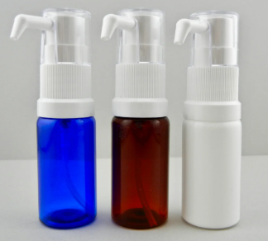  Product Definition & Scope  Product: (Cleanroom manufactured), multi-dose plastic bottles integrated with a precision metering pump.  Primary Use: For the accurate dispensing and administration of allergen extract solutions in sublingual immunotherapy (SLIT).  Key Specifications & Compliance:  - Material: Medical-grade PET or HDPE (such as S3, S4 series), compatible with common allergen extracts.  - Pump Performance: Consistent, calibrated drop volume per actuation (e.g., 0.05ml or 0.14ml) to ensure dosing accuracy.  - Design: User-friendly for both healthcare professionals during compounding and patients during home use. Tamper-evident features may be incorporated.  - Regulatory Pathway: As a container closure system for a drug, it will be developed and supplied in compliance with current Good Manufacturing Practices (cGMP) and relevant FDA guidance for container closure systems.
REQUEST TYPE | ☐LCR (Labelling Change Request)  Changes on the labels without changing the products  ☐SCR (Supplier Change Request)  Change applications initiated by Suppliers  ☐ECR (Engineering Change Request)  Existing products that SOLM is the legal manufacturer  Engineer changes that are not bringing new hazards/risks  ☐NPD (New Product Development)  Develop new innovative products that SOLM will be the legal manufacturer  Significant changes on existing products that may bring new hazards/risks or new intended use  Change products from outsourcing to SOLM to be the legal manufacturer  Development of VET/Component products  ☐SDP (SOLM Distributor Product)  New product introduction that SOLM will not be the legal manufacturer  No change on the product, no SOLM information on the labels  ☒SPP (SOLM Portfolio Product)  New product introduction that SOLM will not be the legal manufacturer  No change on the product, Add SOLM information on the labels  ☐Customized Product / Market  Purchased products that SOLM is not the legal manufacturer  Engineering change on products or new customized products requested by SOLM  New Market region requested by SOLM
TARGET MARKET: | ☒ US ☐ Canada ☐ EMEA ☐ UK ☐ Brazil ☐ Australia & New Zealand ☐ Other countries/regions, list:
TARGET USE: | ☒ Human Use  ☐ Animal Health | STERILE | ☐ YES  ☒ NO
VOLUME/SALES OPPORTUNITY: | Launch volume required: | Yr 1 estimate | Yr 2 estimate
CUSTOMER NOTIFICATION | Do we have any special quality agreement in place with customer which requires approval before implementing changes? ☐ YES ☒ NO  If Yes, please provide the customer's name and evidence.  Attach the customer confirmation GF-0083 at the end of the form.  Is notification to the customers needed after change project is closed? ☐ YES ☒ NO  Remark:  Example: change affect regulatory, performance, appearance, etc. Notification method.
LEGAL MANUFACTURER: | ☐ Sol-Millennium  ☒ Other: __________ | BRANDING | ☒ Sol-Millennium  ☐ Private Label
EXPECTED PRODUCT LAUNCH PERIOD: | ☒ < 1 year  ☐ 1-3 year  ☐ > 3 years | EXPECTED PRODUCT LIFE PERIOD: | 10 years
NAME AND DATE of REQUEST: | Alex Lu 2026/1/29

Business Case & Commercial Rationale

This project targets a high-value, recurrent-purchase item with significant strategic and financial upside.

Product | COO | Den Uni Price | Target Uni Price | Target Gross Margin | Annual consumption in US | Solm Forcast（10% ） | Est. Sale Revenue
15mL White Plastic Bottle（with 50uL Dose） | China | $2.19 | $1.53 | 60% | 15,000,000 | 1,500,000 | 2,295,000
15mL Amber Plastic Bottle（with 50uL Dose） | China
15mL Blue Plastic Bottle（with 50uL Dose） | China
30mL White Plastic Bottle（with 50uL Dose） | China
30mL Amber Plastic Bottle（with 50uL Dose） | China
50uL Metered Dose | China | $2.40 | $1.20 | 60% | 15,000,000 | 1,500,000
140uL Metered Dose | China
15mL White Plastic Bottle | China | $0.75 | $0.38 | 60% | 15,000,000 | 1,500,000
15mL Amber Plastic Bottle | China
15mL Blue Plastic Bottle | China
30mL White Plastic Bottle
30mL Amber Plastic Bottle

